**Evaluating Current Safaricom's Financial Performance: A Comprehensive Analysis of Revenue, Profit Margins and Cash Flow Activities (2022-2024)**

Safaricom, one of the largest telecommunications companies in Kenya, has shown significant financial progress over the past few years. This analysis evaluates the company's performance from 2022 to 2024 based on key financial metrics, including total revenue, net income, EBITDA margin, and net profit margin. The analysis aims to provide a comprehensive overview of Safaricom's current valuation and potential growth trajectory.

**Revenue and Net Income Analysis (2022-2024)**

The analysis of Safaricom’s financial performance from 2022 to 2024 reveals a steady upward trend in both total revenue and net income. Total revenue increased from approximately KShs 298,078 million in 2022 to KShs 310,905 million in 2023, and further to KShs 349,447 million in 2024. The growth rate in revenue varied over this period: a modest increase of 4.29% from 2022 to 2023 indicates a slow recovery, potentially due to market saturation, competitive pressures, or economic factors. However, a notable 12.38% rise from 2023 to 2024 suggests strong revenue recovery, possibly driven by strategic efforts such as product diversification, expansion in data services, or improved customer retention.

In parallel, net income exhibited significant growth, rising from KShs 43,495 million in 2022 to KShs 69,795 million in 2023, and reaching KShs 95,412 million in 2024. The 60.48% surge in net income from 2022 to 2023 reflects improved operational efficiency and cost management, contributing to enhanced profitability. This consistent increase in both revenue and net income underscores Safaricom’s effective strategic interventions, operational efficiency, and successful leveraging of revenue streams, leading to improved financial resilience and profitability

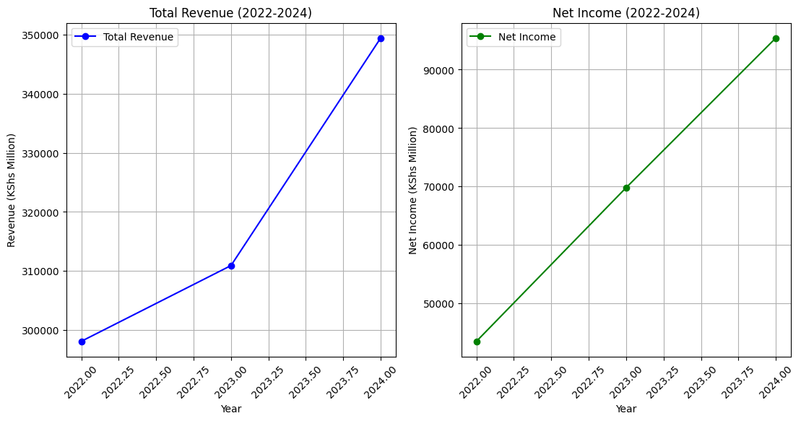

**EBITDA and Net Profit Margin Analysis (2022-2024)**

The comparison of Safaricom's EBITDA margin and net profit margin from 2022 to 2024 reveals a steady improvement in overall profitability. The EBITDA margin experienced a modest increase, moving from 51.36% in 2022 to 53.01% in 2024, which points to consistent core operational efficiency. This stability at the EBITDA level highlights Safaricom's resilience in managing operational costs effectively, even amidst external challenges such as inflationary pressures or intensified competition. A stable EBITDA margin also indicates that the company successfully maintained strong operational profitability, reinforcing its ability to cover direct expenses and sustain core functions efficiently.

In contrast, the net profit margin demonstrated a much more pronounced increase, jumping from 14.59% in 2022 to 27.30% in 2024. This significant rise in net profit margin suggests substantial improvements in overall profitability, likely due to strategic cost management efforts and possibly optimized tax liabilities or interest expenses. The sharp increase also reflects Safaricom's strengthened pricing power, enabling the company to retain a larger share of its revenue as net profit. The growth in net profit margin, coupled with the stable EBITDA margin, underscores Safaricom's capacity to enhance profitability through effective expense control, strategic pricing, and operational efficiency, thus creating greater shareholder value and solidifying its financial foundation.

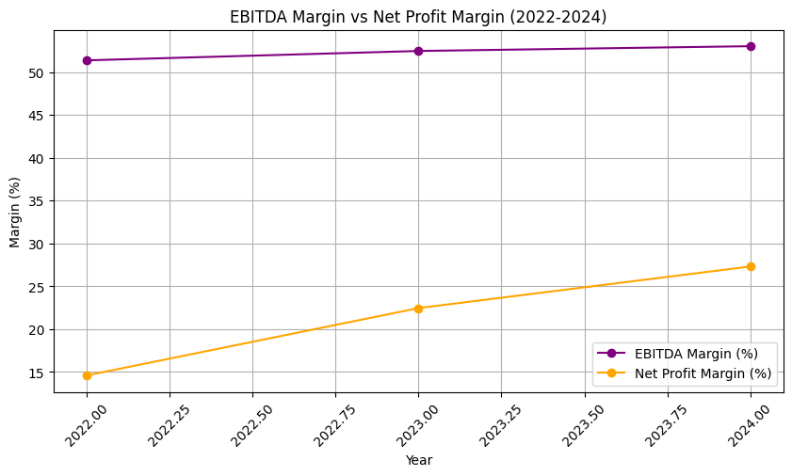

**A Visual Analysis of Safaricom's Cash Flows**

The graph below provides a visual representation of Safaricom's cash flow activities for the years 2022 to 2024. In 2022, Safaricom generated over 100 billion Kenyan Shillings in operating cash flow, indicating strong performance from its core operations, primarily mobile telephony and M-Pesa. However, the company also invested heavily in its business, leading to negative investing cash flow of around 120 billion Kenyan Shillings. To fund these investments, Safaricom resorted to external financing, resulting in a negative financing cash flow of approximately 120 billion Kenyan Shillings. A similar pattern is observed in 2023 and 2024, with strong operating cash flows, significant investment activities, and reliance on external financing. This strategy of balancing growth and financial prudence is crucial for Safaricom's long-term sustainability.

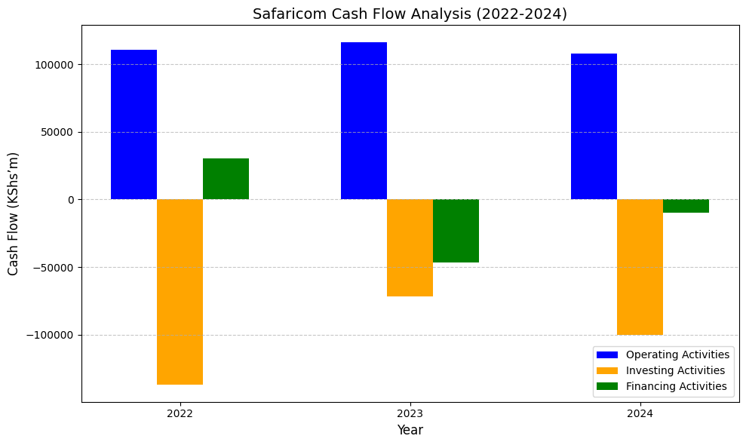

**Conclusion**

Safaricom's financial performance from 2022 to 2024 demonstrates a balanced approach to growth and financial management. The company has shown resilience in overcoming revenue challenges and has consistently improved its profitability. The robust cash flow from operating activities, coupled with significant reinvestments and prudent financial management, underscores Safaricom's commitment to long-term growth and market leadership.

The current valuation of Safaricom, supported by strong financial metrics and a strategic growth outlook, indicates a positive trajectory. As the company continues to expand its service offerings and invest in technology, it is well-positioned to maintain its market dominance and deliver sustained value to shareholders in the coming years